Inside Shame Transformation
with Caryn Scotto d’ Luzia, MA, SEP, Developer of AST Model of Holistic Shame Resolution®

I recently had the honor of working with an 80-year-old client, a magnificent embodiment teacher and leader in her own right. When she first came to me, she was spinning in such shame-chaos that a crucial legal document needing attention remained unaddressed, which only compounded her shame, self-blame, and worry, and increased real world consequences. She was stuck. So I asked her to bring the document to her session.
A while into our time together, I asked her about it. She began dismissing it as not worthy of our time. I asked her what it might feel like in her body to have the document filled out and in the mail. She immediately began breathing more deeply.
“It would be a relief,” she confessed.
“Can we spend the next 10 minutes looking it over and moving on if it’s not helpful?” I asked.
She nodded.
She attempted to read it, but she couldn’t. “Here!” She thrust the document under my nose as though it were dirty laundry.
I read and began nonchalantly filling it out with her.
Ten minutes passed, leaving another five to complete the task. She agreed, and we walked the document to the mailbox together. There were still 15 minutes remaining in the session.
“I am such a failure. I can’t believe at this age I needed you to hold my hand to get to the mailbox.”
I shrugged. “I don’t know. I rather enjoy the process. I found it old fashioned and sweet, and I am wondering if it would be okay to allow yourself, for two minutes, to feel your worry lift and experience what satisfaction and accomplishment can offer your body?”
She shrugged. “If you make me.” She half teased.
“Well, I care about you and the quality of your life to gently insist.” I said, and smiled as I began the timer.
“Wow, that’s confusing.”
“Someone supporting you to think about what is best for you?”
“You got that right,” she said.
There was a lot of this kind of back and forth filled with hesitation, disbelief, bewilderment and being touched and feeling supported, until she began to pick up and initiate these supportive more satisfying impulses for herself.
Shame forms a barrier around experiencing a sense of true accomplishment. For chronic shame survivors, a goal or aspiration represents yet another set up for failure, humiliation and hopelessness. Learned shame leads to learned hopelessness and a deep sense of inadequacy. It’s the complete opposite of empowerment. Plus, learned hopelessness creates a self-fulling prophecy.
Shame distorts our judgment about the world, others, and especially about ourselves. It forms a harbor for self-doubt and anxiety and/or rumination around that doubting. Attempting to move forward to accomplish something, regardless of how badly it may be desired, calls forward an army of self-doubt or a cascade of depressive and freeze-like neuro-signaling. If disgust is an emotion that was bound with the original shame-wound the person will feel disgusted by his/her own self-doubt.
To make matters worse, one’s ability to clearly think through next steps and components necessary for satisfaction, accomplishment or success become muddled and elusive. Progress feels completely out of reach.
The work looks different with other clients, each situation calling for its own individual approach; yet, the common thread involves creating a deep container of compassionate relentless around deserving something other than chaos, shame, worry, criticism and guiding the client toward something less shaming—this is a critical component of shame transformation. In each case the work is attuned, real, close to the bone, and life-changing.
Clients experience themselves differently because of this kind of holding and resonance that the AST Model makes available to them. Below, I offer what I see as some intervening shifts that allow for the overall transformation process.
Specific Tips:
- Keep clients moving forward even if in the tiniest of ways.
- Help your clients find the support and resources that meet their level of challenge.
- Support your clients to think through plans and necessary steps.
- Assist your clients to envision themselves feeling satisfied and successful.
- Guide clients through their feelings of undeserving of success or deserving only failure.
- Make space to explore being on the other side of the shame state.
- Normalize being stuck as a natural part of processing their shame.
- Uphold the reality that despite the depth of their shame, your clients CAN get to the other side where wonderful life-affirming and satisfying behaviors, emotions, thoughts and experiences await them!
When applied in sessions these steps create very powerful intervening shifts that build on themselves and breakthrough many of these habituated cycles. Your clients deserve the freedom shame resolution work affords, and you deserve the reward of watching your clients BLOOM this summer:)!

Dear Boulder Therapeutic Community

I am writing to remind you about an exciting learning opportunity coming soon right here in Boulder! AST Model of Holistic Shame Resolution® Intro: Boulder, CO, June 23rd, 6-8:30pm. Don’t let the opportunity to sign up for your complimentary pass, pass you by.

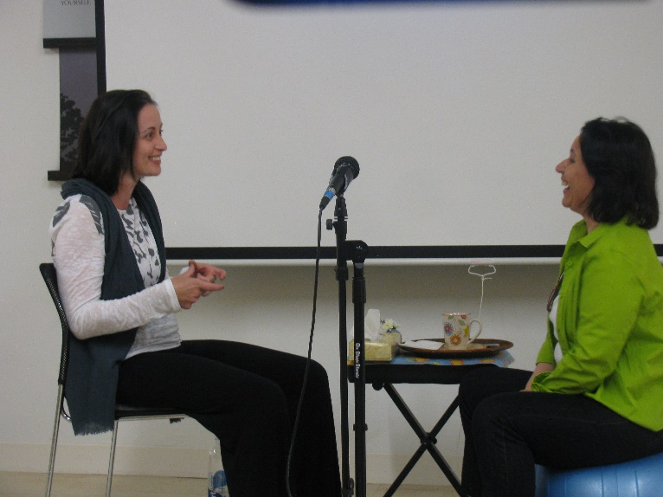
As professionals and students of life-affirming transformation you have studied the gold standards in trauma recovery and other therapeutic work. Now you can learn how to resolve shame for even the most impacted chronic shame and trauma survivors through the gold standard in shame resolution work: AST Model of Holistic Shame Resolution®. This eye-opening model provides professionals with a new and inspiring framework that addresses working with shame’s challenges and clients with whom nothing seems to work. Be inspired to empower your client’s to live a life of greater worth, connection, acceptance and belonging.

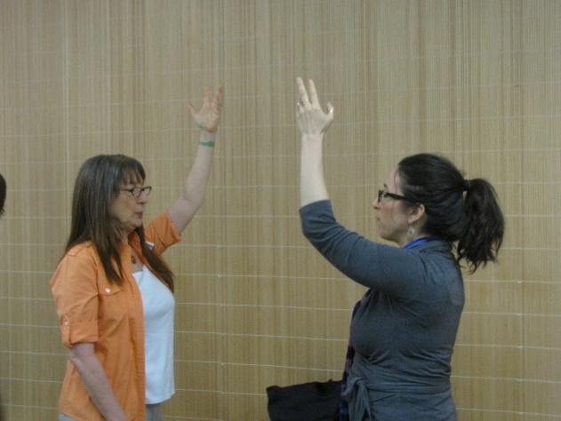

EXPERIENCE AST MODEL LIVE with DEVELOPER CARYN SCOTTO D’ LUZIA
AST Model Intro: Boulder, CO, June 23rd, 6-8:30pm
BodyWork Bistro Living Arts Center, 3825 Iris Ave., Boulder, CO
Please join AST Model developer on June 23rd, from 6-8:30pm here in Boulder, for a complimentary, LIVE Intro to the AST Model®. This event will include 14 paradigm shifts of AST Model theory, dynamic group work, and a live Demo. Find out what it takes to move core stuckness forward. You will never experience shame the same way again. Space is limited, and once filled, we will take names on a waiting list basis. Don’t miss this rare opportunity. Contact Brigid Whitehead to RVSP: btwhitehead@mac.com or call 303-907-5357.

“I found the AST Model work excellent. I am in the SE track and hope to take the 3 Day AST Model training upon my completion of Adv II. The AST Model provides helpful concepts as I work with my own and clients shame cycles. Truly the gift of transforming shame-- as AST Model named, it is about restoring the authentic self so I can move with more space and ease in my life and help others to do the same! Caryn, keep up your awesome work!”

Ann, SE Student

“I am excited about AST Model's post advanced offering!! It has shown me that understanding and addressing shame is central to healing our deepest wounds.
As someone who has lived with chronic shame, I felt a sweet relief sitting with Caryn. As I absorb this experience over time, I have had fewer “Shame attacks.” Where self-loathing and self-reproach used to be a daily experience I now feel freer to express myself in the world.
Caryn’s teachings have also helped me more easily recognize the difficulty my clients have in tolerating their own shame states and how their attempts to block this painful experience become the source of many problem behaviors they seek to change.”
Tori B., SEP Assistant

“I am thrilled the AST Model is going out in wider and wider circles. With this work, a chunky missing piece of body wisdom is snapping into place. I have been using AST Model’s "naval intelligence" regularly with the teens I work with and it is helping them so much! Really, really life changing.”
Linda E. Erman, MPS, LCAT, SEP

AST Model of Holistic Shame Resolution® Level 1
for SEPS, Psychologists, Social Workers, Licensed Addiction Counselors & Healing Professionals
21 CEs for Psychologists, Social Workers, MFTs and LPCs
24 SETI Post Advanced Credits for SEPs + CEs
This September, Caryn Scotto d'Luzia, author of Alchemy of Shame Transformation and Developer of AST Model of Holistic Shame Resolution® will offer a post-advanced training as an internal part of SETI’s new post-advanced credential program. If you are and SEP you can earn 24 Post-Advanced SEP Credits and CEs while you learn to resolve shame. If you aren't somatic-based, but you are a social worker, MFT, LPC, or psychotherapist you can earn 21 CEs while you discover how to lift the shroud of shame within yourself and for those you serve.
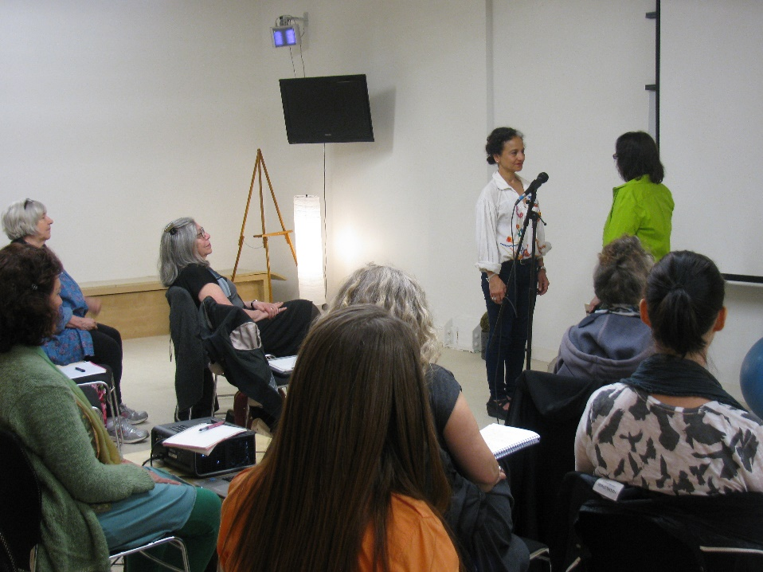
Participants will learn to discover the unique qualities needed to meet clients in their shame wound. Equally important, participants will gain the tools necessary for building shame resilience. Participants will never look at shame the same way again! Be inspired to empower your client’s to live a life of greater worth, connection, acceptance and belonging.

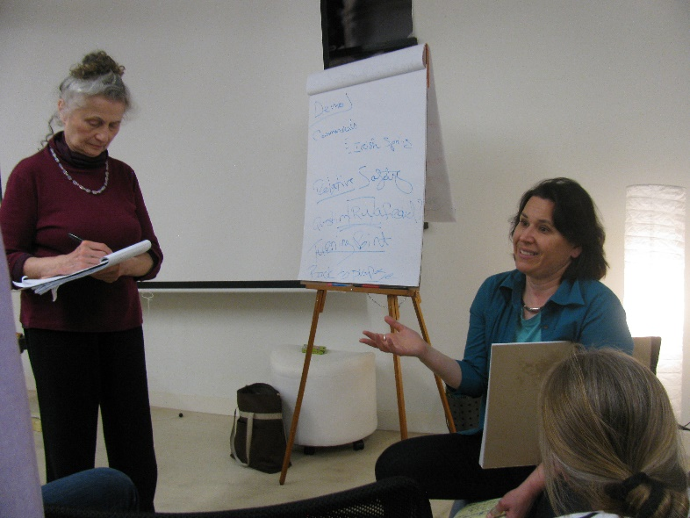
Register for LIVE AST Model Level 1 Training: Boulder, CO, Sept, 23rd-25th
BodyWork Bistro Living Arts Center, 3825 Iris Ave., Boulder, CO
Earn 24 Post-Advanced SEP Credits and CEs while you learn to resolve shame!
This eye-opening training will provide participants with a new and inspiring framework that will address working with shame’s challenges and clients with whom nothing seems to work!

“I am grateful for how much I have been enlightened both personally and professionally using the AST Model. It has helped me to reach another layer of deeper understanding. As I specialise in trauma, working with shame enables trauma to be processed much quicker, and more deeply.”
H. M., BA Psych, DipEd, BHSc, DipNut, DipPsych, DRT, ND, EMDR, SEP

“I have been an SE assistant for many, many years. I love SE and still do. But I knew for me something was missing. I was lucky to have a chance to study AST Model work and have a session with Caryn. I didn’t realize how life changing this model would be!”
Anonymous SEP Assistant

FOR MORE INFO:
To learn more about Caryn and the AST Model®, please visit: https://www.re-embodylife.com. Should you have questions about the 3-Day training please contact me at jennifersilaccilcsw@gmail.com or call 877-640-7337.

Caryn Scotto d’ Luzia is an innovative somatic facilitator, educator and trainer. She is developer of AST Model of Holistic Shame Resolution®, a neurobiologically–principled, attachment based approach that specializes in chronic shame relief, building shame and inner critic resilience, healing shame-based early trauma, facilitating shame-based attachment re-patterning, and supporting life-affirming authentic self-expression and empowerment.
She is the author of the following ebooks and articles, Alchemy of Shame Transformation for Therapists and Healing Professionals (AST), The 5 Step Journey to Healing Social Phobia, The Yin/Yang of Abandonment Recovery, and Wound & Essence: A Call and Response Approach to Transformation. She is leading a shame-free living movement and training therapists, healers, and community leaders how to facilitate shame resolution and cultivate acceptance, connection, belonging, worth and well-being.
Caryn works face-to-face with people around the world on Skype, and in-person in the California’s Bay Area and New York City where she sees adult clients. She offers phone case consults to therapists, healers, and coaches as well as teaches neurobiological principles through webinars online. On a wider scale, she collaborates with UN affiliated NGOs and Governments to heal collective trauma and post conflict PTSD. She is a Somatic Experiencing Practitioner and SETI adjunct faculty member, a member of the UN NGO Committee on Mental Health, USABP presenter, and speaker at the United Nations on the issue of resolving shame in women and girls around the world.

